RESOLUTION NO.__________

RE: CERTIFICATE OF APPROPRIATENESS UNDER THE
PROVISIONS OF THE ACT OF THE PENNSYLVANIA
LEGISLATURE 1961, JUNE 13, P.L. 282 (53
SECTION 8004) AND BETHLEHEM ORDINANCE NO.
3952 AS AMENDED.

WHEREAS, it is proposed to install handrails on both sides of front steps at 129 E. Market St.

NOW, THEREFORE, BE IT RESOLVED by the Council of the City of Bethlehem that a Certificate of Appropriateness is hereby granted for the proposal.

Sponsored by: (s)

(s)

ADOPTED BY COUNCIL THIS DAY OF

(s)
President of Council

ATTEST:

(s)
City Clerk

HISTORICAL & ARCHITECTURAL REVIEW BOARD

The applicant proposes to install handrails on both sides of front steps at 129 E. Market St.
APPLICATION #3:

Bruce & Kim Campbell
129 E. Market St.
Bethlehem, PA 18018

Bethlehem, PA 18018

OWNER:

__________________________________________________________________________

The Board upon motion by Beth Starbuck and seconded by Marsha Fritz adopted the proposal that City Council issue a Certificate of Appropriateness for the following:

- New rails to be installed on both sides of three sets of steps.

2. To be in black and have top rails only with posts at top and bottom risers.

3. Rails to be finished in a black powder coated finish.

4. The motion was unanimously approved.

__________________________________________________________________________

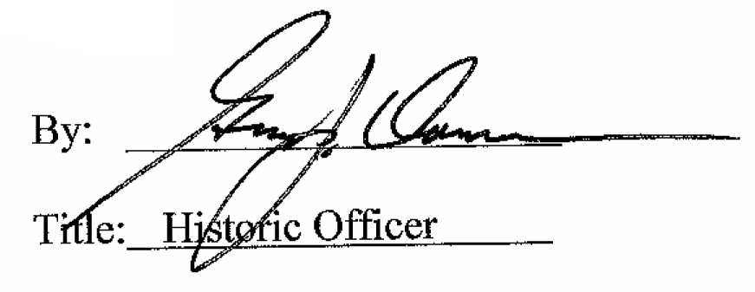

Date of Meeting: May 4, 2016

